Numbers - XAT Level

https://www.facebook.com/events/365698687239109/

Lets start with Question.

1) For how many numbers n between 100 and 300, does n^2 end in a 41?

Concept for Question1 in pic:

Using point 1,

First find smallest square ending with 41, its 21^2=441 . So the desired numbers will be (50-21),(50+21),(100-21),(100+21),.....(300-21)

We need from 100 to 300 so just 121,129,171, ...279.. total 8 of them

Oa : 8

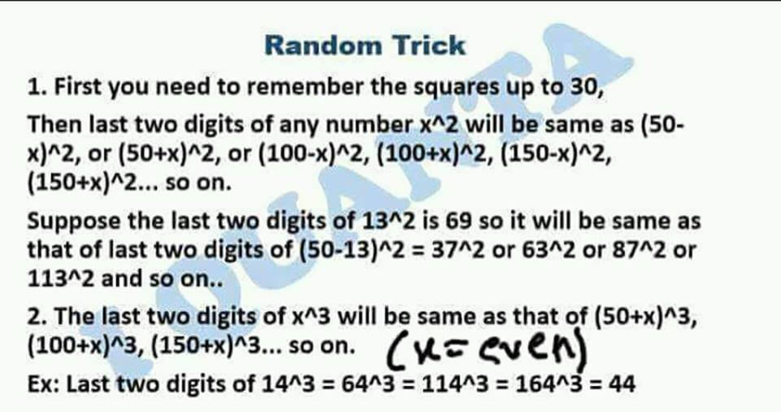

Learn squares upto 30 and table upto 30.

3) For how many 3 digit numbers n, does n^3 end with a 44 ? (Last year Mock question)

 Oa : 18   
  
The smallest number which has last two digits as 44 is 14^3  
  
So all the three digit numbers will be 114, 164, 214....964 .. total : 18  
  
Or can be calculated as (964-114)/50+1=18.  
  
●(Last term - First term)/(difference) +1

in cube the smallest number should be cube root ie. 14^3 has last 2 digits as 44 and not 14^2.

remember cubes upto 30.

[#Digital](https://www.facebook.com/hashtag/digital?source=feed_text) sum

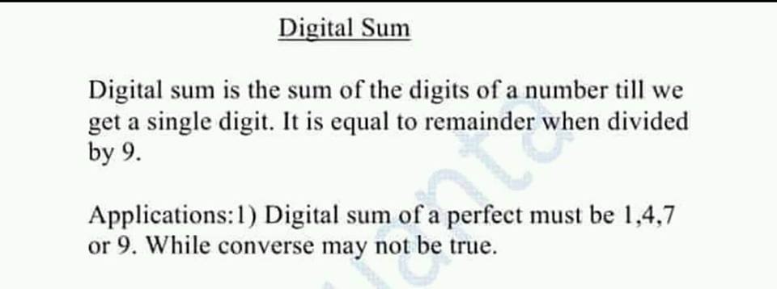

Application 2: Digital sum of perfect cubes=1,8 or 9.

1,4,7,9 for squares   
1,8,9 for cubes

Digital sum is nothing but remainder with 9.

Q. Digital sum of 358^46 is ?

Oa : 7.  
  
Remainder with 9.  
  
358^46 mod 9  
  
E(9)= 6, 46 mod 6 = 4  
  
=> 2^4 mod 9 = 7

Q. Sum of sum of sum of sum of sum of digits of 25! Is?

25! mod 9 = 9

Sum of sum of. .. digits is nothing but repeated sum of digits.   
  
So same as digital sum.  
  
So just find remainder with 9.   
  
25! Mod 9 = 0   
  
But digital sum can never be 0 So we write it as 9.

Remember few properties !!

Naam yaad rakhna zaruri nhi h

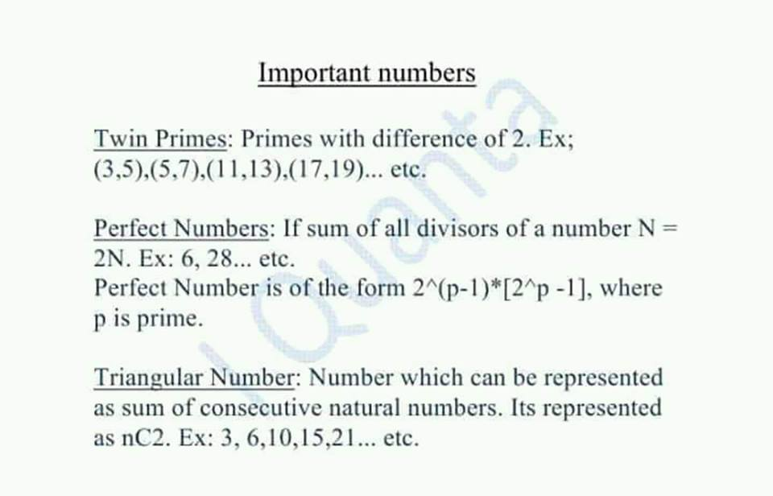

Truangular :Any number which can be presented as sum of first few numbers  
  
Like : 1+2+3+...n

nC2 = n(n-1)/2   
  
Replace n with n+1 => n(n+1)/2   
  
ie sum of first n numbers

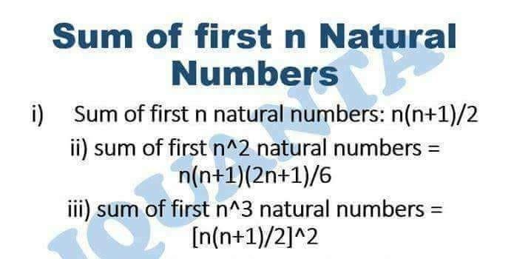

 rth Triangular number can be written as r(r+1)/2

1   
  
1+2=3   
  
1+2+3= 6  
  
1+2+3+4= 12   
  
1+2+3+....n   
  
All on Rhs are triangular numbers  
  
Hit like if understood

50(2+200) = 10100  
50(1+199)= 10000  
  
Applying AP formula (n/2)*(first+last)

**a) sum upto n even terms n(n+1)   
  
B) sum upto n odd terms = n^2**

or Odd  
  
Sn=(n/2)[2a+(n−1)d]  
  
Sn=(n/2)[2a+(n−1)d],   
  
where a is the first term and d is the common difference.  
  
For this question, a=1 and d=2. Thus:  
  
Sn=(n/2)[2+(n−1)*2]  
  
Sn=(n/2)[2+(n−1)*2]  
  
Sn=n^2

Q.Find the number of 3 digit natural numbers which are neither divisible by 4 nor 9 ?

 Total :

900  
  
Divisible by 4 : 900/4= 225  
  
Divisible by 9 : 900/9=100  
  
Divisible by both: 900/lcm(9*4)=25   
  
Required : 900-225-100+25=600

Or just  
  
Euler 900(3/4)(8/9)= 600

Cyclicity: application of euler  
  
Range : 900  
  
Not divisible by 4 in first 4 : 3   
  
Not divisible by 9 in first 9 : 8  
  
Required not divisible by both  
  
900(3/4)(8/9)=600

Non terminating are ones which doesn't end after decimal and keeps on going. Now there are two types involved

●Recurring(repeating) and non terminating => Rational

Like those with repeating pattern, 1.333..... , 5.444..., 7.565656....

these are Rational Numbers, as 1.33... can be written as 4/3, ie p/q form

● Non recurring non terminating => Irrational

Those with no such pattern, like 1.3763378..... , 7.46754... , pi, etc

It was done in first class... is it Clear ?

Application based

Q) A rational number A/B , where A and B are co-prime, is converted into a decimal number. If both A and B are less than 100, then for how many valuesof B will A/B always be a terminating decimal?

 For terminating decimal, in base 10 = 2*5  
  
denominator must be of the form 2^a*5^b ( all combinations of 2 and 5)   
  
So B = 2^a*5^b less than 100  
  
2^0 to 2^6 : 7  
5^1,5^2 : 2  
2*5 , 2*5^2, 2^2*5, 2^3*5, 2^4*5 : 5  
  
Total= 7+2+5= 14 values

Denominator me 2 and 5 powers k form me number ho tabhi terminating decimal aata h... simple na https://static.xx.fbcdn.net/images/emoji.php/v9/f9f/1/16/1f61b.png:p

Remember it. Useful. Last concept from Numbers chapter.

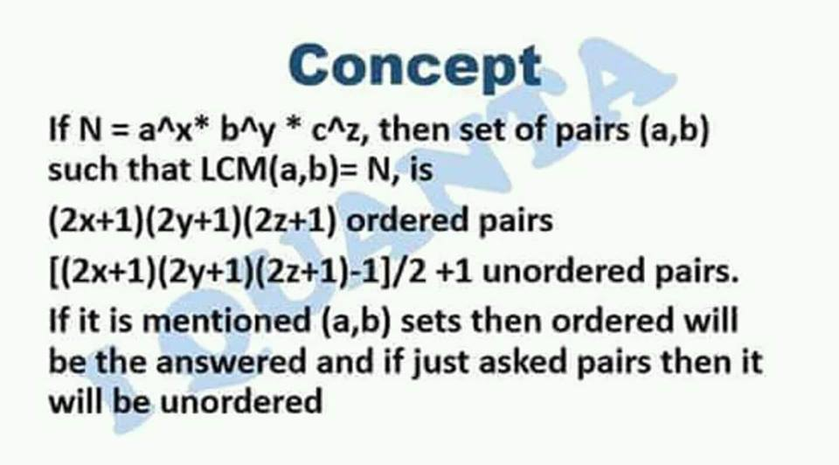

**For unordered pairs:**

**+1 is only added when we consider (1,1)**

**so usually we never add +1.**

**dont add +1 is specifically not given in question.**

Q. How many pairs of natural numbers are there such that their LCM = 36 ?

 36 = 2^2*3^2   
  
So total pairs [(2*2+1)(2*2+1)-1]/2+1  
  
Oa : (5*5-1)/2+1=13  
  
Ordered if variables were given

The HCF of how many distinct pairs of factors of 18000 is 75?

lcm = number / hcf

lcm = 18000/75

HCF*LCM = product of numbers (property )  
  
So hcfxlcm= product of factors = 18000  
  
=> 75*LCM = 18000   
=> LCM = 18000/75 = 240   
  
Now,  
LCM pairs = 2^4 * 3 * 5   
  
=> [(2*4+1)(2*1+1)(2*1+1)-1]/2 +1  
= 41

Q. Number of coprime pairs of factors of 100 are ?

hcf 1 ho jaega iss case me

100 = 2^2 *5^2   
  
Manually:  
(1,1) (1,2),(1,4),(1....100) : 9  
(2,5),(2,25)  
(4,5),(4,24)   
  
Total 13   
  
Answer would be 12 if repition not allowed. (1,1) would be excluded)   
  
Technically previous formula also gives the answer 13  
  
[(2*2+1)(2*2+1)+1]/2=13  
  
Why ?   
  
Hcf * Lcm = 100   
  
Coprime => means HCF = 1   
  
So 1 * Lcm = 100   
  
=> Lcm= 100   
  
So apply previous formula.

Number of coprime pair of factors of 20 is ??

(2*2+1)(2*1+1)/2 = 8   
  
8-1= 7 if repition not allowed

[#Assignment_Questions](https://www.facebook.com/hashtag/assignment_questions?source=feed_text)

1) What is the remainder when we divide 3^90 + 5^90 by 34?

2) Remainder when [100!+1] divided by 101 is ?

3) Remainder when 32^33^34 divided by 7?

4) Remainder when 3^450 is divided by 108?

5) what's unit digit of 7^11^22^33 ?

6) what's unit digit of 17^27! ?   
7) The numbers 1 to 33 are written side by side as follows: 12345...33. What is the remainder when it's divided by 9 ?

8) what's last two digits of 52^(122!) ?

9) How many factors of 36^36 are perfect squares ?

10) How many factors of 2^11*3^8*5^9 are perfect cubes ?

11) (34^47)^48 divided by 17 then remainder = ?

12) A number N=x⁴-x³ is perfect cube for how many natural values of x belonging from 1 to 500 ?

13) Sum of all even factors of 2^6*3^4*5

14) Sum of all odd factors of 14^5*24^3 is ?

15) 57! Mod 61 = ?

16) 555555.... Upto 302 digits divided by 37 then remainder = ?

17) How many Pairs of numbers natural numbers have LCM = 540 ?

18) How many factors of 3^4*12^3*5^7 are neither perfect square nor cubes ?

19) Minimum number with 84 divisors is ?

20) 47^32^32 mod 7 = ?

0, 0,1, 81, 7, 1, 3, 01, 1369, 48, 0, 7, 45738, 2372568, 51, 18, 53, 365, _ , 2

Factors assignment link https://www.facebook.com/indrajeetsinghrock/videos/1677498238960385/

Solution live

https://www.facebook.com/iquanta.iquanta/videos/603645883311858/